Summary - Int 2, Group C, 𝚫𝚫G Version

Inbal Lorena Eshel

03/02/25

# *Intermidiate 2*

### Model 3P

| formula | R.sq | Q.sq | MAE |
| --- | --- | --- | --- |
| ddg ~ NPA_1 + Total_1 + B5_3_9 | 0.787 | 0.661 | 0.232 |
| ddg ~ NPA_6 + Total_1 + B5_3_9 | 0.772 | 0.648 | 0.229 |

***Multicollinearity check***

|  | x |
| --- | --- |
| NPA_1 | 1.012 |
| Total_1 | 1.129 |
| B5_3_9 | 1.131 |

***Scaled Coefficients:***

|  | Estimate | Std. Error | t value | Pr(>|t|) |
| --- | --- | --- | --- | --- |
| (Intercept) | 0.146 | 0.056 | 2.605 | 0.0184943 |
| NPA_1 | 0.188 | 0.058 | 3.248 | 0.0047281 |
| Total_1 | -0.265 | 0.061 | -4.341 | 0.0004444 |
| B5_3_9 | -0.411 | 0.061 | -6.721 | 0.0000036 |

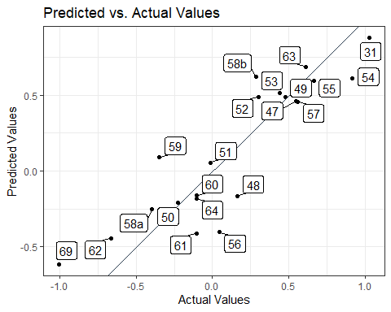

### Model 4P

| formula | R.sq | Q.sq | MAE |
| --- | --- | --- | --- |
| ddg ~ NPA_5 + dip_z_1 + Total_1 + B5_3_9 | 0.878 | 0.769 | 0.200 |
| ddg ~ NPA_1 + dip_z_1 + Total_1 + B5_3_9 | 0.857 | 0.740 | 0.194 |

***Multicollinearity check***

|  | x |
| --- | --- |
| NPA_5 | 1.177 |
| dip_z_1 | 1.038 |
| Total_1 | 1.323 |
| B5_3_9 | 1.158 |

***Scaled Coefficients:***

|  | Estimate | Std. Error | t value | Pr(>|t|) |
| --- | --- | --- | --- | --- |
| (Intercept) | 0.146 | 0.044 | 3.340 | 0.0041540 |
| NPA_5 | 0.183 | 0.049 | 3.752 | 0.0017418 |
| dip_z_1 | 0.188 | 0.046 | 4.112 | 0.0008159 |
| Total_1 | -0.349 | 0.052 | -6.765 | 0.0000045 |
| B5_3_9 | -0.458 | 0.048 | -9.488 | 0.0000001 |

